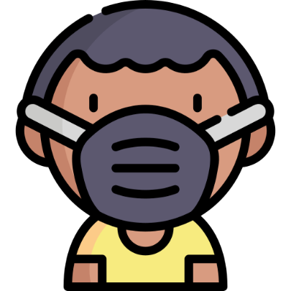

|  |
| --- |
| **Protection Webinar**  Hi Jeffy,  You are invited to join the Protection webinar on Tuesday at 9:00.  See you soon! |